Looping Statement
____________________________________________________________________________________
Q. what is loop?
_________________________________________________________________________
Loop means if we want to perform some task repeat again and again called as loop.
There are two types of loop
___________________________________________________________________
1. Entry control loop: entry control loop means first we check the condition and after that decide loop will be execute or not called as entry control loop.

There are two types of entry control loop.
________________________________________________________________
a) while loop.
b) for loop
2. Exit control loop: exit control loop means first execute the loop and after that check condition called as exit control loop.
a) do while loop.
If we want to work with any loop we have three types of statement
a) Initialization: initialization means to decide from loop will start
b) Condition: condition means to decide how many times loop will be repeat or decide number of iterations.
c) Increment or decrement: steps to increment or decrement mean to decide the gap between every iteration.

while loop
_______________________________________________________________________________
Syntax:
initialization;
while(condition){
write here your logics
increment or decrement;
}
Example: we want to print the good morning five times using while loop.
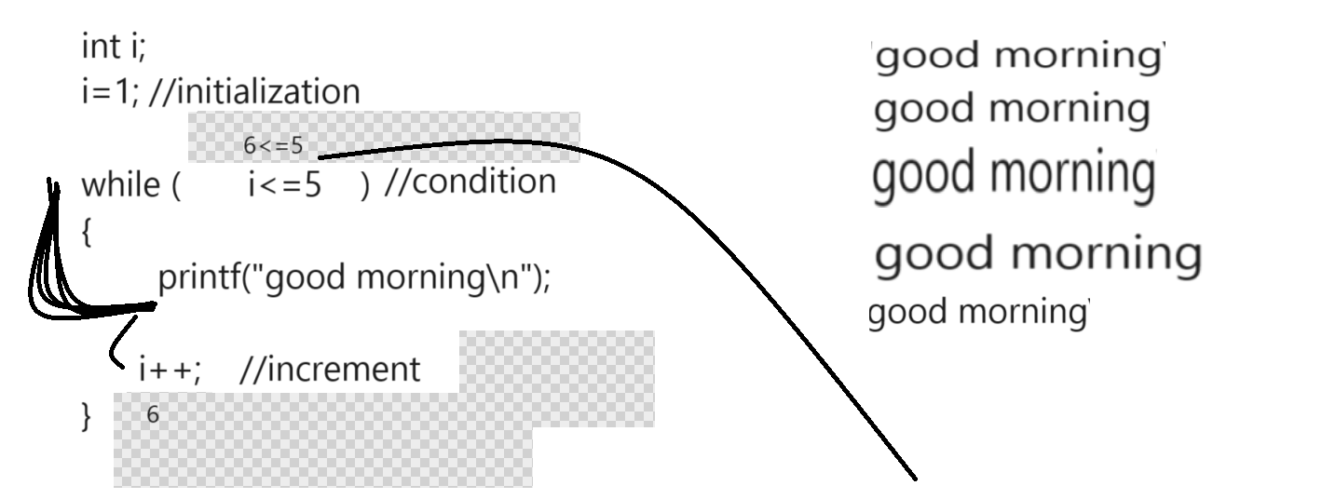
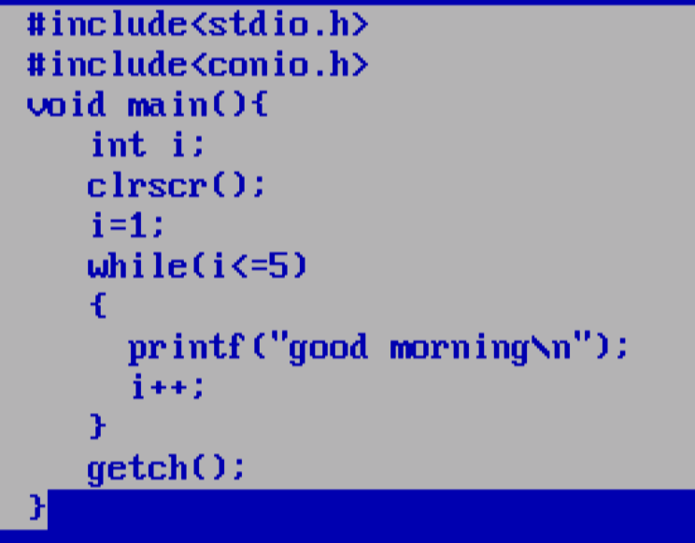

Example: WAP to calculate the sum of all natural number between 1 to 10

Example: WAP to input two values consider first as base and second as index and calculate its power

5
3
3
Output: 5 = 5 x 5 x 5 = 125

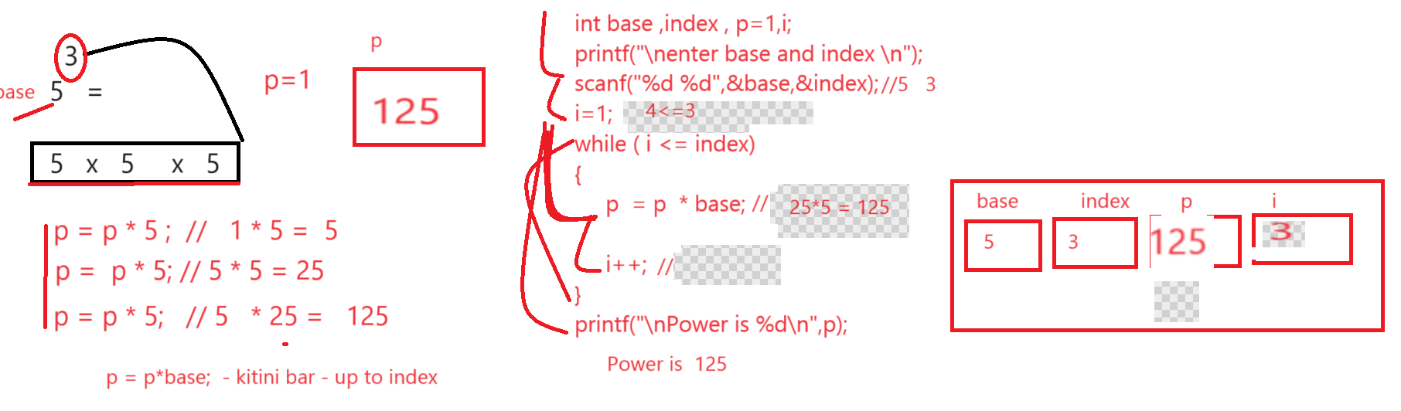

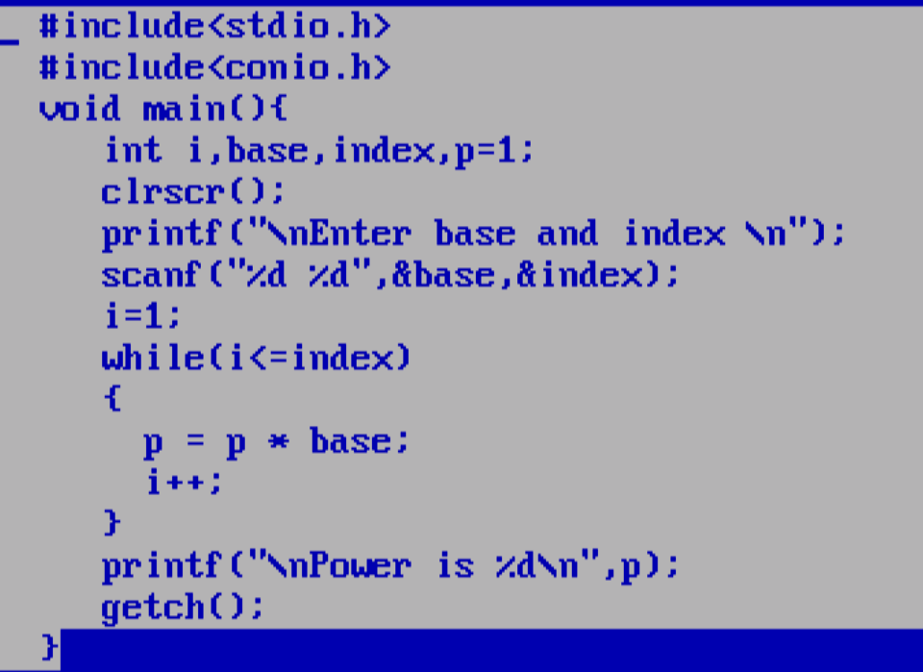

Example: WAP to input number and calculate its factorial.

5 = 5 x 4 x 3 x 2 x 1 = 120

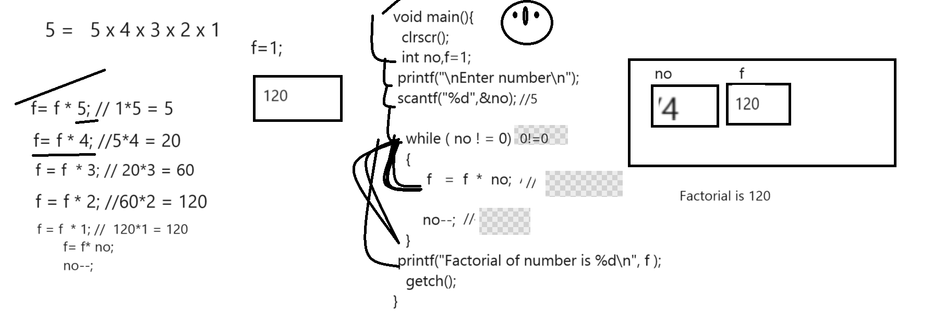

Example: WAP to input the number and check number is perfect or not
Note: perfect number means number sum of its all divisor is equal with number
Example: 6 is perfect number
1 2 3= 1+2+3 = 6

8 = 1 2 4 =1+2+4= 7

Example: WAP input the number and check number is duck or not
Duck number means number contain 0 called as duck number
Example: 1024 - it contain 0 so we can say 1024 is duck number
Example: 1234 – here not 0 present in number so we can say it is not duck number
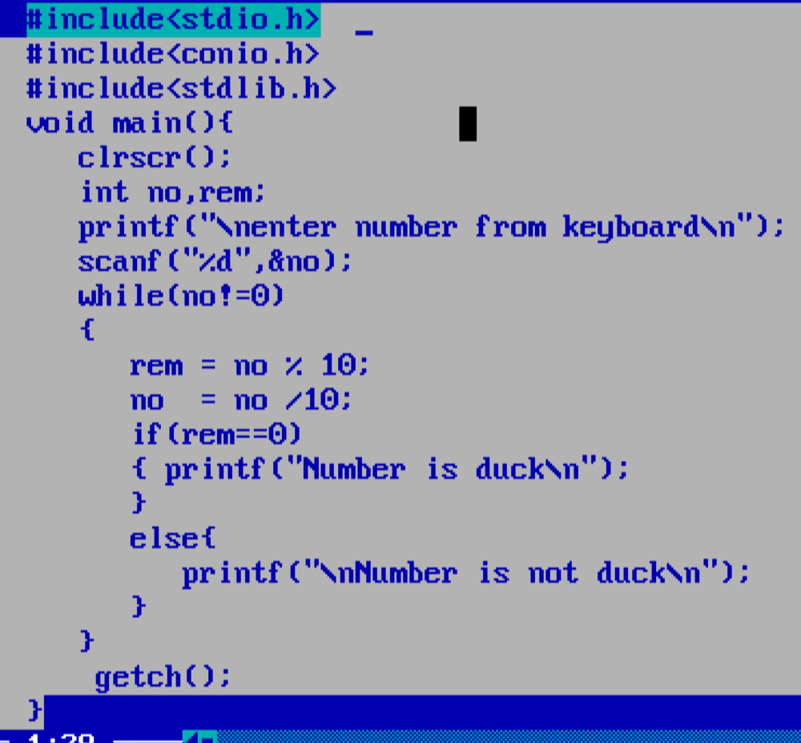
Output:
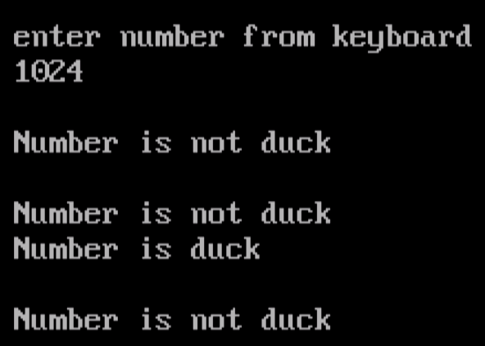
If we think about above output there is no proper because our program print 3 times not duck and 1 time duck so it is not predicated output because we expect program should single time number duck or either number is not duck.
so if we want to solve this problem we have to use flag variable concept in program
Q. what is flag variable in c program?
_______________________________________________________________
flag is term in coding which indicate either true or false value so in the case of c language we use the variable which where we set its initial value as 0 and in loop we use the if condition and if condition satisfy we set its value as 1 and terminate loop and after loop we check condition and decide the result.

Q. why use flag variable?
___________________________________________________________________________
Normally if we think about loop and if we use the if else in loop then either if or else get executed so both true and false condition get executed every time so program cannot generate the predicated output to us so in this not write if else in loop just write single if in loop and check the condition if condition is satisfy then set flag variable as 1 means true and terminate the loop and after loop you can write single if else and if condition is true then execute the if block otherwise not
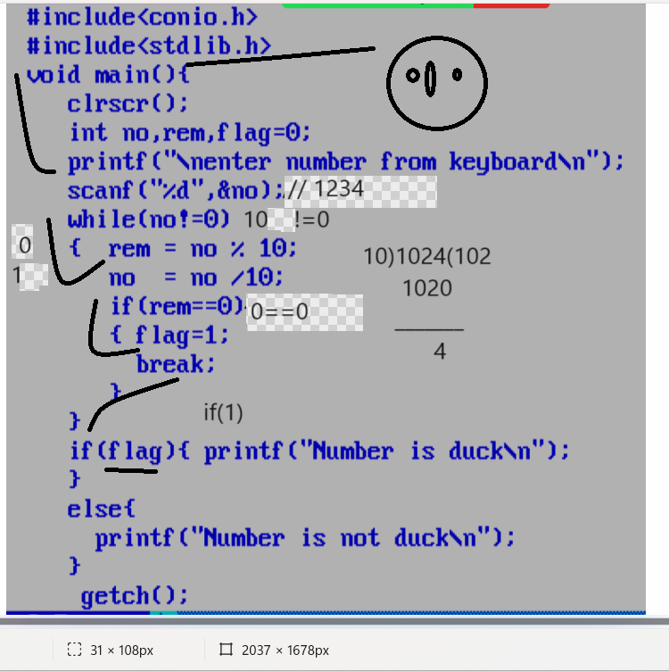

Example: WAP to input number and search digit present in it or not
Input: 12345
Enter search digit
3
Output: digit found
Input: 12345
Enter search digit
8
Output: digit not found.

Source code
#include<stdio.h>
#include<conio.h>
void main(){
clrscr();
int no,rem,flag=0,skey;
printf("\nEnter number\n");
scanf("%d",&no);
printf("\nEnter search key value\n");
scanf("%d",&skey);
while(no!=0)
{
rem = no % 10;
no = no /10;
if(rem ==skey)
{ flag=1;
break;
}
}
if(flag)
{ printf("Digit found");
}
else{
printf("Digit not found");
}
getch();
}

Example: WAP to input the number and swap its first and last digit.

#include<stdio.h>
#include<conio.h>
#include<math.h>
void main(){
long int no,last,first,p,p1,count=0,temp;
clrscr();
printf("\nEnter number from keyboard\n");
scanf("%ld",&no);
temp=no;
printf("\nBefore swapping digit %ld\n",no);
while(no!=0)
{ no = no /10;
++count;
}
no=temp;
p=pow(10,--count);
last=no%10;
first=no/p;
no=no/10;
p1=pow(10,--count);
no=no%p1;
last=last*p;
no=no*10;
no=last+no+first;
printf("\nAfter swapping Digit %ld\n",no);
getch();
}

Example: WAP to input number and check number is Armstrong or not
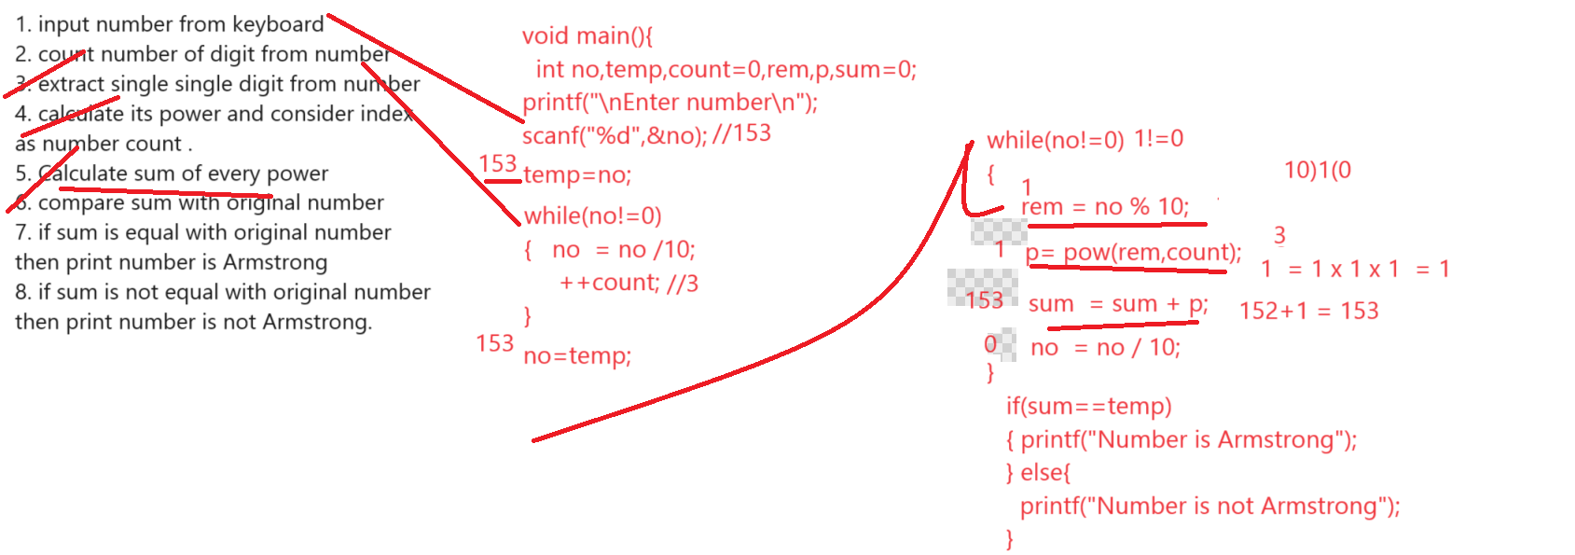
Source code
#include<stdio.h>
#include<conio.h>
#include<math.h>
void main(){
int no,rem,p,count=0,temp,sum=0;
clrscr();
printf("\n\nEnter number \n");
scanf("%d",&no);
temp = no;
while(no!=0)
{
no=no/10;
++count;
}
no=temp;
while(no!=0)
{ rem = no % 10;
p=pow(rem,count);
sum=sum+p;
no=no/10;
}
if(sum==temp)
{ printf("Number is armstrong");
}
else
{
printf("Number is not armstrong");
}

getch();
}
Example: WAP to print the fibonacii series
0 1 1 2 3 5 8 13

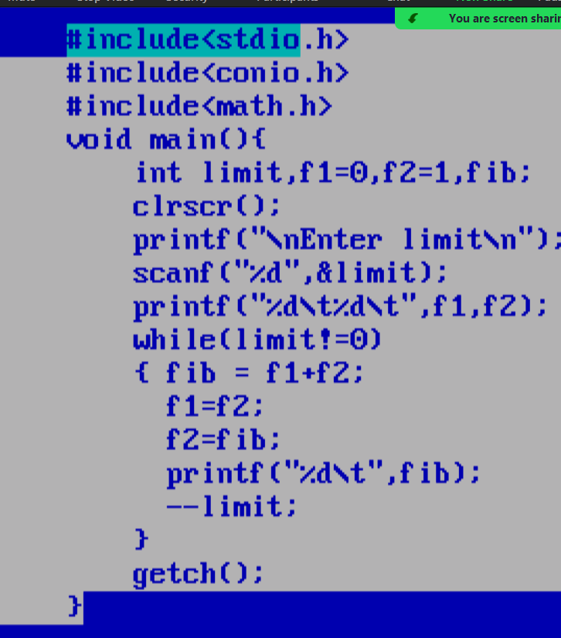

Example: WAP input the number and search number present in Fibonacci series or not
0 1 1 2 3 5 8 13

Input number
5
Number present in fibonacii
Input number
7
Number not present in fibonacii

For Loop
____________________________________________________________________________________
for loop is same like as while loop with some major differences

Syntax: for(initialization; condition; increment or decrement)
{
}
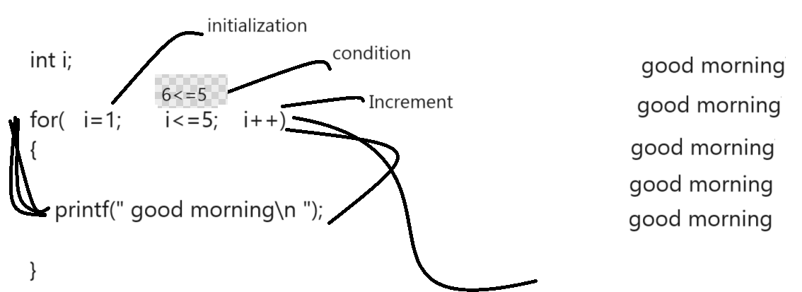

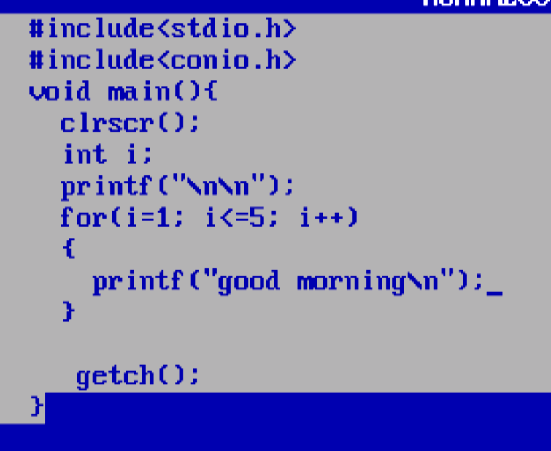

Ways to write for loop
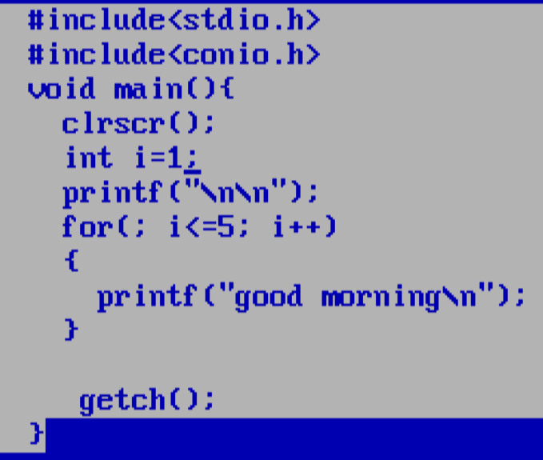
Second way to write for loop.
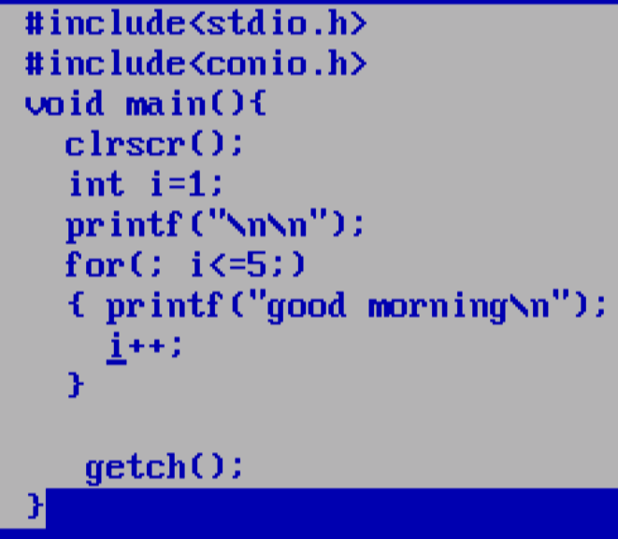
Third way to write for loop
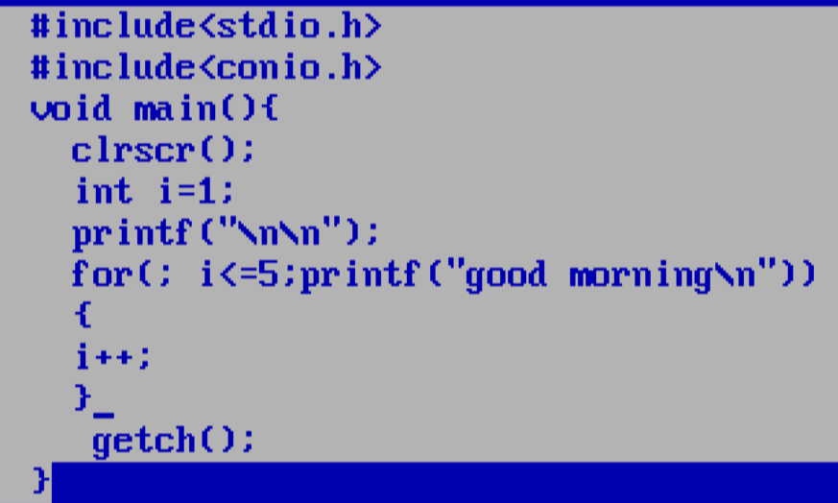
Example: WAP to input number and print its table using for loop.
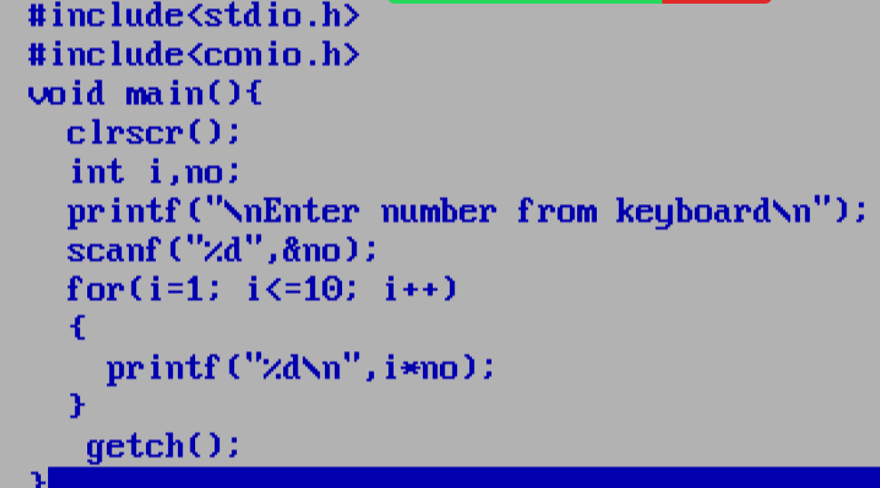

Nested for loop
___________________________________________________________________________
Nested for loop means for within for called as nested for loop.
Nested for loop specially designs for work with matrix means when we want to work with row and column then we can use nested for loop.
Syntax:
for(initialization; condition; increment or decrement) //outer for loop or row
{
for(initialization; condition; increment or decrement) //inner for loop or column
{
write here your logics
}
}
Note: when we work with nested for when outer loop execute only once then inner loop execute all times.
Example:
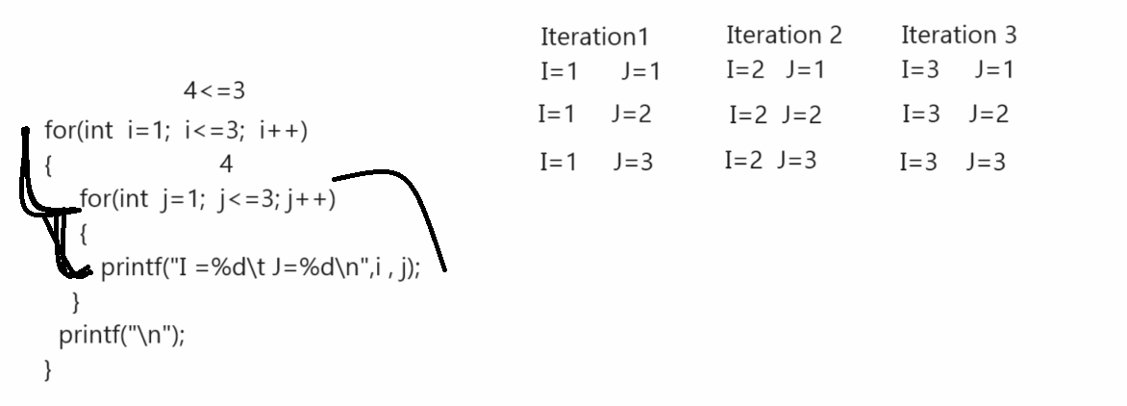
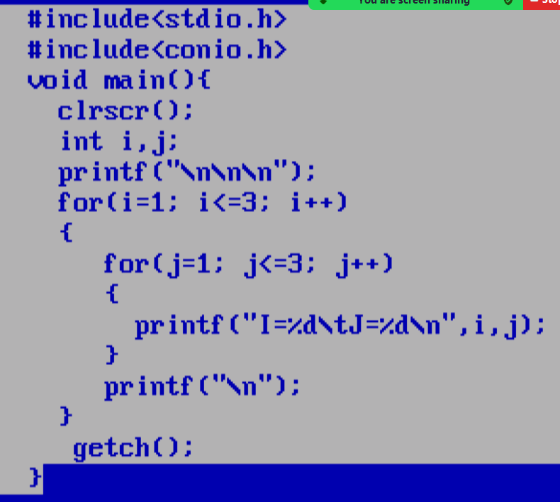

Example: WAP to print tables from 2 to 10
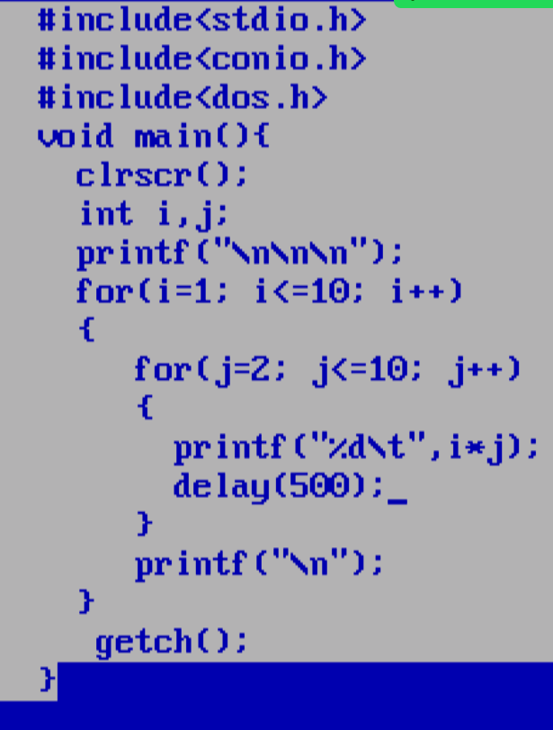

Output:
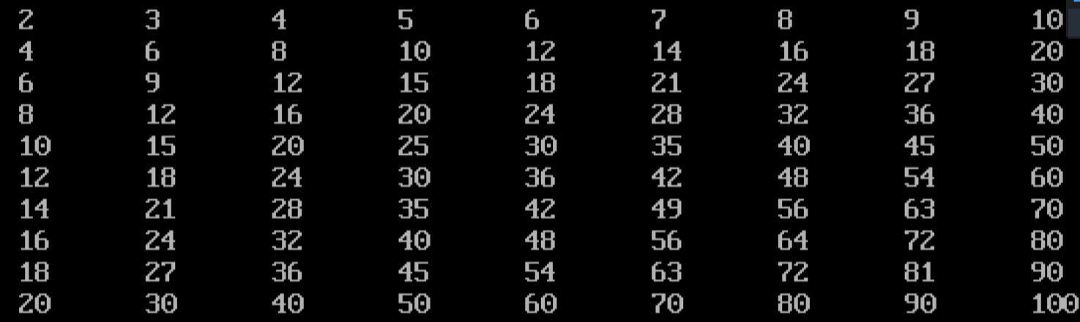

Example: WAP to print the following pattern
Output:

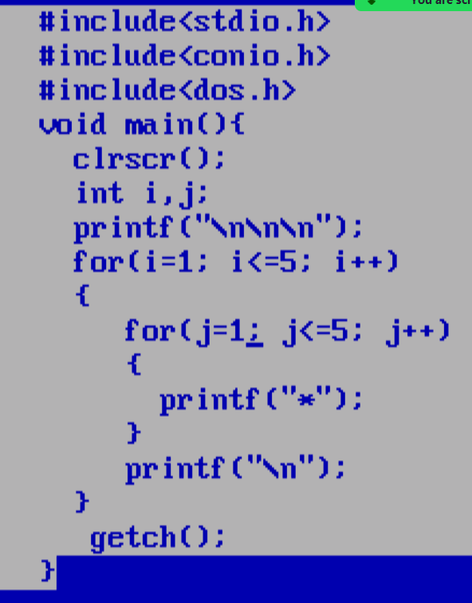

Example: WAP to Print the following pattern.

